1. **Introduction to Named Entity Recognition case study: IBM models.**

Named Entity Recognition (NER) is a critical task in natural language processing that involves identifying and classifying entities such as names of people, organizations, locations, dates, and more within a text.

**Equation:**

While there isn't a specific mathematical equation for NER, the task often involves the use of machine learning algorithms such as Conditional Random Fields (CRF) or deep learning models such as Recurrent Neural Networks (RNNs) and Transformers.

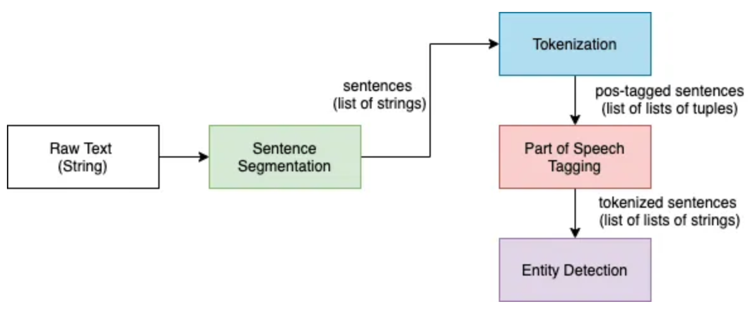  
 **Algorithmic Steps:**

* **Tokenization:** Break down the input text into tokens (words or subwords).
* **Feature Extraction:** Extract relevant features from the text, such as part-of-speech tags, word embeddings, and contextual information.
* **Model Training:** Utilize machine learning models like CRF, RNNs, or Transformer-based models to train on labeled datasets.
* **Prediction:** Apply the trained model to new text for predicting named entities.

### 3. Applications of NER:

* **Information Retrieval:** Enhance search engines by identifying and indexing entities in documents.
* **Question Answering Systems:** Improve the accuracy of systems that answer questions by understanding the entities mentioned.
* **Sentiment Analysis:** Recognize named entities to better understand the sentiment associated with specific entities.

### 4. Recent Trends in NER:

* **Deep Learning Dominance:** Recent trends show a shift towards deep learning models, especially Transformer-based architectures like BERT and GPT, due to their ability to capture contextual information effectively.
* **Multilingual NER:** Growing interest in developing NER models capable of handling multiple languages to support global applications.
* **Transfer Learning:** Leveraging pre-trained models and fine-tuning them for specific NER tasks to improve performance.

Pseudo code:

# Pseudo code for a simple NER model using spaCy

import spacy

# Load English NER model

nlp = spacy.load("en_core_web_sm")

# Process text

text = "Named Entity Recognition is crucial for information extraction."

doc = nlp(text)

# Extract entities

entities = [(ent.text, ent.label_) for ent in doc.ents]

# Print identified entities

print(entities)

### 6. Tools for NER:

* **Python Libraries:** Utilize popular NLP libraries such as spaCy, NLTK, and scikit-learn for implementing NER models in Python.
* **Open Source Tools:** Explore open-source tools like Stanford NER and Flair for NER tasks, providing flexibility and customization options.

2. **Advanced Language Modeling (including LDA)**

**Definition:** Advanced Language Modeling involves the use of sophisticated algorithms to understand and generate human-like language, going beyond basic language processing tasks. LDA, specifically, is a probabilistic model that uses for ALM.

**Equation:**

**Diagrams:**

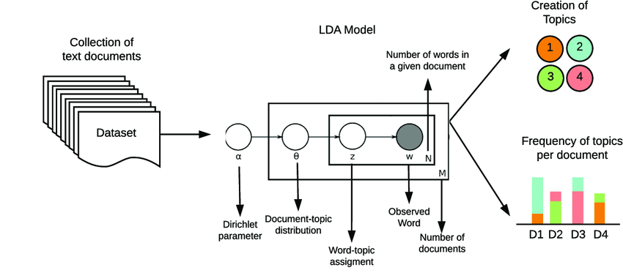

### 2. Algorithmic Steps for Latent Dirichlet Allocation (LDA):

* **Initialization:** Assign each word in each document to a random topic.
* **Iterative Optimization:**
  + Calculate the probability of each word belonging to a topic and each document containing a topic.
  + Reassign words to topics based on calculated probabilities.
  + Repeat the process until convergence.
* **Output:** Topics are identified, and each document is represented as a distribution of topics.

### 3. Applications of Advanced Language Modeling:

* **Topic Modeling:** Discover latent topics within a collection of documents, aiding in document clustering and organization.
* **Recommendation Systems:** Enhance content-based recommendation systems by understanding the underlying topics in user preferences.
* **Content Summarization:** Summarize large volumes of text by extracting and highlighting key topics.

### 4. Recent Trends in Advanced Language Modeling:

* **Transformer Models:** The rise of Transformer models like GPT-3 and BERT has revolutionized language modeling, offering superior performance in capturing contextual information.
* **Multimodal Language Models:** Integration of language models with other modalities such as images and audio for a more comprehensive understanding.
* **Zero-shot Learning:** Recent advancements in zero-shot learning, enabling models to perform tasks on new data without task-specific training.

### 5. Pseudo Code for LDA:

# Pseudo code for Latent Dirichlet Allocation using the Gensim library

from gensim import corpora

from gensim.models import LdaModel

from nltk.tokenize import word_tokenize

# Preprocess the documents and create a dictionary and corpus

documents = [...] # List of documents

tokenized_docs = [word_tokenize(doc.lower()) for doc in documents]

dictionary = corpora.Dictionary(tokenized_docs)

corpus = [dictionary.doc2bow(doc) for doc in tokenized_docs]

# Train the LDA model

lda_model = LdaModel(corpus, num_topics=3, id2word=dictionary)

# Print the topics

print(lda_model.print_topics())

### 6. Tools for Advanced Language Modeling:

* **Python Libraries:** Gensim and spaCy are powerful libraries for implementing advanced language models, including LDA, with ease.
* **Open Source Tools:** Mallet is an open-source Java-based package that includes efficient implementations of LDA for topic modeling.

### 3. Summarization:

#### - Definition and Importance:

* **Definition:** Summarization involves condensing a large piece of text while retaining its essential information and meaning. It can be extractive (selecting and combining existing sentences) or abstractive (generating new sentences).
* **Diagrams** :

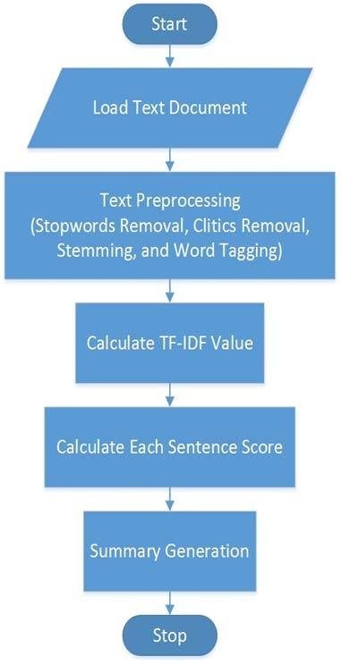

#### - Algorithmic Steps for Extractive Summarization:

* **Sentence Scoring:** Score each sentence based on features like term frequency, sentence length, and the importance of words.
* **Sentence Selection:** Select sentences with the highest scores to form the summary.

#### - Algorithmic Steps for Abstractive Summarization:

* **Encoder-Decoder Architecture:** Utilize an encoder-decoder neural network architecture, where the encoder processes the input text, and the decoder generates a concise summary.
* **Attention Mechanism:** Integrate attention mechanisms to focus on important parts of the input during the summarization process.

#### - Applications:

* **News Summarization:** Quickly summarize news articles for readers who want a brief overview.
* **Document Summarization:** Condense lengthy documents for easier understanding and quick review.
* **Meeting Summarization:** Automatically generate summaries of meeting discussions for efficient collaboration.

#### - Recent Trends:

* **Pre-trained Language Models:** Leveraging pre-trained language models like BERT for abstractive summarization to capture contextual information effectively.
* **Multimodal Summarization:** Incorporating images or other modalities in the summarization process for a more comprehensive summary.

#### - Pseudo Code for Extractive Summarization:

# Pseudo code for extractive summarization using the TextRank algorithm

from gensim.summarization import summarize

# Input text

text = "Large piece of text..."

# Generate extractive summary

summary = summarize(text)

print(summary)

#### - Tools for Summarization:

* **Python Libraries:** Gensim, NLTK, and spaCy provide tools for both extractive and abstractive summarization.
* **Open Source Tools:** BART (Facebook's BART model) is an open-source pre-trained model suitable for abstractive summarization.

### 4. Information Retrieval Question Answering (IRQA) Systems:

#### - Definition and Importance:

* **Definition:** IRQA systems aim to provide precise and relevant answers to user queries by extracting information from a given dataset or knowledge base.
* **Diagrams:**

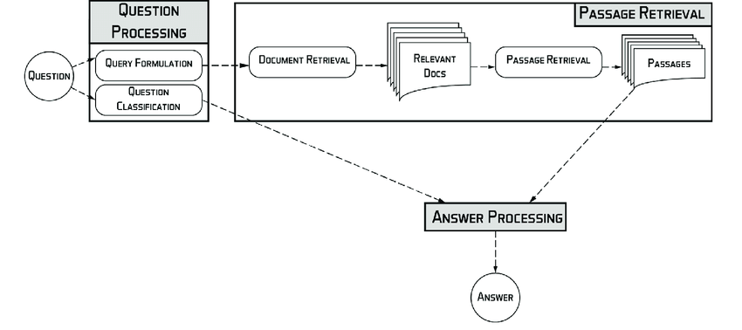

#### - Algorithmic Steps:

* **Query Preprocessing:** Tokenize and process user queries to extract relevant keywords.
* **Document Retrieval:** Retrieve documents from the dataset that contain relevant information based on the processed query.
* **Answer Extraction:** Extract answers from the retrieved documents using techniques like named entity recognition or information extraction.

#### - Applications:

* **Customer Support:** Provide quick and accurate answers to customer queries in real-time.
* **Search Engines:** Enhance search engine capabilities by directly providing answers to user queries.
* **Virtual Assistants:** Enable virtual assistants to respond effectively to user questions.

#### - Recent Trends:

* **BERT and Transformer Models:** Integration of transformer models like BERT to better capture context
* in user queries.
* **Knowledge Graphs:** Utilizing knowledge graphs to enhance the understanding of relationships between entities for better answers.

#### - Pseudo Code for IRQA System:

# Pseudo code for a simple IRQA system using spaCy and TF-IDF

import spacy

from sklearn.feature_extraction.text import TfidfVectorizer

# User query

query = "User query..."

# Dataset documents

documents = [...]

# Tokenize and process the query

processed_query = spacy_tokenizer(query)

# TF-IDF vectorization

vectorizer = TfidfVectorizer()

tfidf_matrix = vectorizer.fit_transform(documents)

# Calculate cosine similarity between query and documents

cosine_similarities = cosine_similarity(tfidf_matrix, vectorizer.transform([processed_query]))

# Retrieve the document with the highest similarity

most_similar_document = documents[np.argmax(cosine_similarities)]

print(most_similar_document)

#### - Tools for IRQA Systems:

* **Python Libraries:** spaCy, scikit-learn, and Hugging Face Transformers for building and deploying IRQA systems.
* **Open Source Tools:** Elasticsearch and Solr are open-source search engines that can be adapted for building effective IRQA systems.